Samuel Bloxham, Zack Hawkins, Sebastian Michalak, Josie Wood

Word count:  [-----]

ISAD: Group Report

# Modelling

Modelling • Initial entity relationship diagram • Results of normalisation • Final entity relationship diagram

Initial ERD

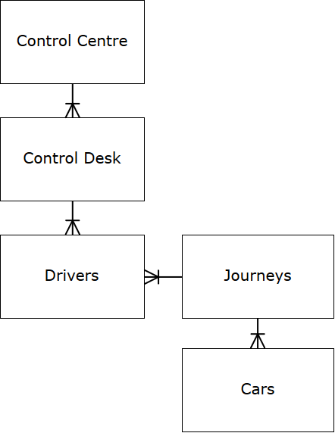

Assumptions:

* Journeys are made by cars, not drivers

Normalisation

|  |  |  |  |
| --- | --- | --- | --- |
| **UNF** | **1NF** | **2NF** | **3NF** |
| **Control Centre** | **Control centre** | **Control centre** | **Control Centre** |
| Control Desk | Control desk | Control desk | Control Desk |
| (Call ID | Vehicle reg | Vehicle reg |  |
| Customer first name | Car make | Car make | **Control Centre** |
| Customer last name | Passenger capacity | Passenger capacity | **Call ID** |
| Home tel. # |  |  |  |
| Mobile tel. # | **Control centre** | **Control centre** | **Call ID** |
| Address | **Call ID** | Call ID | Customer ID |
| Comment) | Customer ID | Customer ID | Driver ID |
|  | Driver ID | Driver ID | Pick up Address |
| (Customer ID | Pick up address | Pick up address | Pick up Postcode |
| Pick up address | Pick up postcode | Pick up postcode | Date/Time |
| Pick up postcode | Drop off address | Date/time | Drop off Address |
| Drop off address | Drop off postcode | Drop off address | Drop off Postcode |
| Drop off postcode | Note | Drop off postcode | Note |
| Date/time | Card # | Note | Card # |
| Note |  | Card # |  |
| Card #) | **Control centre** |  | **Control Centre** |
|  | **Customer ID** | **Control centre** | **Customer ID** |
| (Driver ID | Customer first name | **Customer ID** |  |
| Driver first name | Customer last name |  | **Customer ID** |
| Driver last name | Home tel.# | **Customer ID** | Customer first name |
| Days working | Mobile tel. # | Customer first name | Customer last name |
| Shift) | Address | Customer last name | Home tel. # |
|  | Comment | Home tel. # | Mobile # |
| (Vehicle reg |  | Mobile # | Address |
| Car make | **Control centre** | Address | Comment |
| Passenger Capacity) | **Driver ID** | Comment |  |
|  | Driver first name |  | **Control Centre** |
|  | Driver last name | **Control centre** | **Driver ID** |
|  | Days working | **Driver ID** |  |
|  | Shift |  | **Driver ID** |
|  |  | **Driver ID** | **Vehicle reg** |
|  |  | Driver first name | Driver first name |
|  |  | Driver last name | Driver last name |
|  |  | Days working | Days working |
|  |  | shifts | Shifts |
|  |  |  |  |
|  |  |  | **Vehicle Reg** |
|  |  |  | Car make |
|  |  |  | Passenger capacity |
|  |  |  |  |

# Database development

Database Development • Queries employed to produce your database • Queries employed to retrieve the information listed in Section 1.5.

# Evaluation/ Critical review

Evaluation / Critical Review • Problems encountered and any deviations from the design with reasons • Suitability and completeness of the solution • Further work—what else you would like to do and what you would do differently?

Problems encountered

* When we received the data set for customers we found that it had a home postcode for each customer, which is an attribute we didn’t pick out from the brief. This means we need to alter our database from our 3NF as we need to add a postcode column to the customers table, because otherwise when we read the data there’s more than we have allocated space for, causing it to error.
* We had trouble importing data from the .txt files into our database without creating new tables from the data or converting the files into .csv format, both of which don’t appear to apply with our briefing. As such, we have discussed our issue with Chris [add solution here when we’ve successfully imported data].

Suitability and completeness of solution

What would we do differently?

# Group involvement

Group Involvement • Project Plan Template: Have all members of the group contributed equivalently to the final submission? Use the provided Project Plan template to indicate the amount of work each member of the group has produced. The Project Plan Template can be downloaded from the DLE—find it under the Coursework Section.

|  |  |  |  |  |  |
| --- | --- | --- | --- | --- | --- |
| **Activity** | **Expected Start Date** | **Estimated Hours (per person)** | **Actual Start Date** | **Actual Hours Spent on this activity** | **Work Carried Out by** |
| **Data Model (ERD)** | 11 February | 10 | 19/02/19 | 2 | Sam |
| 2 | Seb |
| 2 | Zack |
| 2 | Josie |
| **Data Model (Normalisation)** | 18 February | 10 | 19/02/19 | 7 | Sam |
| 7 | Seb |
| 7 | Zack |
| 7 | Josie |
| **Development (MySQL)** | 25 February | 30 | 12/03/19 | 2 | Sam |
| 2 | Seb |
| 4 | Zack |
| 2 | Josie |
| **Report Writing** | 11 February | 10 | 26/02/19 |  | Sam |
|  | Seb |
|  | Zack |
| 2 | Josie |